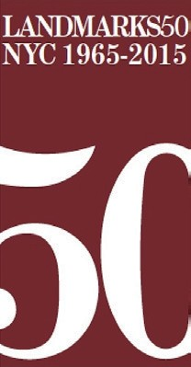
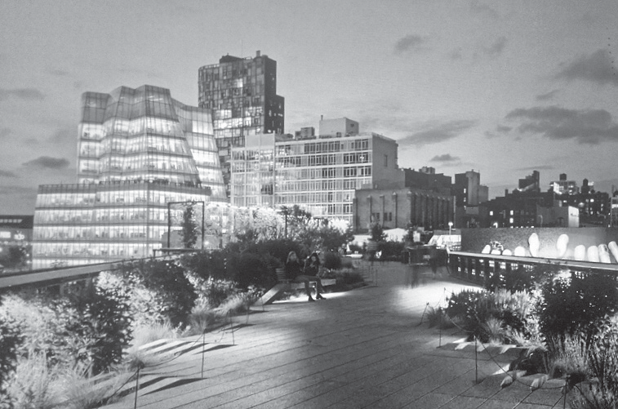
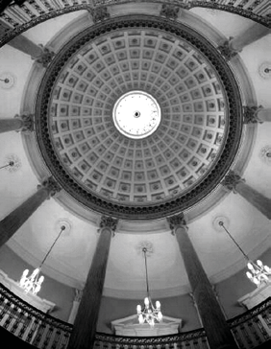
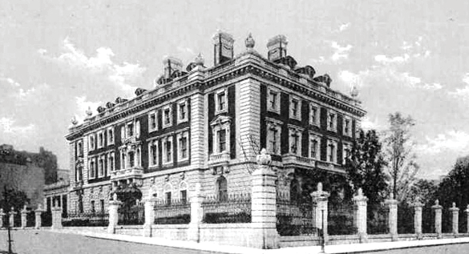
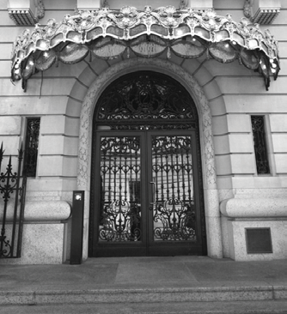
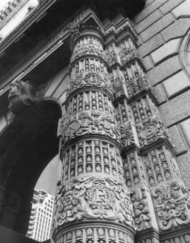
AMERICAN-SCOTTISH FOUNDATION® ARTS & CULTURE PROGRAM
SPONSORSHIP AND PATRON OPPORTUNITIES
The American-Scottish Foundation is proud to have a vibrant
and growing platform of Arts and Culture programming.

A leading project for the ASF at this time is The Scots Who Built New York, a series of talks chronicling the impact of Scots and Scottish Americans on the development of New York.

Having completed the research and presentations from 1664 to the Modernists of today, we now enter Phase 2 of the project, bringing this important and fascinating history to a wider audience through:
- The Scots Who Built New York City Book (in various formats)
- The Scots Who Built New York City Walking Tour App
- The Scots Who Built New York City Map

To date, The Scots Who Built New York lecture series reflects on eras of architecture as exemplified by a leading Scottish architect of the time. Noted within the research and talks are references to other contemporary, leading Scottish American architects.

With the work around the Walking Tour App, and NY City Map, we intend to expand on that research and add in other Scottish American Landmark buildings that were built over the last 350 years.

We invite you to join us as a Sponsor or Patron of this exciting next phase of this project.

Scottish Americans and Scottish architects have been a leading force in the developing of New York and remain so today. ASF were invited to expand on the topic under the working title The Scots who Built Americas Great Cities – our first being a talk in Washington DC in October 2016, an ever expanding project!

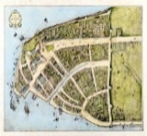
1664-1750 October lecture (October, upcoming) The Scots part of the development of the City from its Dutch beginnings. Robert Livingston, a Scot, came to New York in the 1670s and became one of the wealthiest men in the Colony. Among his business associates was Captain William Kidd, a Scot from Dundee who sailed a privateer, financed by Livingston and others. Later was accused of being a pirate. Before the accusations Kidd was a prominent Citizen of the City and helped to establish Trinity Church, among other city improvements.
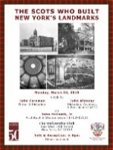
1763-1845 John McComb Jr. and his father John Sr. were major architects and builders during the reconstruction of NYC after 10 years of British occupation following the Revolution. John McComb Jr has 8 extant Landmarks in NYC, more than any other architect to date. Among them is City Hall, Alexander Hamilton's home The Grange, and St Mark’s Church.

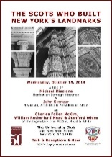
1845-1900 Charles McKim was senior partner in McKim Mead and White, the premier architectural firm in the United States at the turn of the 20th Century. McKim overcame personal setbacks to become one of the finest architects of the century.
Amongst his outstanding buildings are The Loeb Library and The University Club, his jewel. We suffer at the loss of Pennsylvania Station, which in passing led to the creation of NYC's Landmark Preservation Commission.

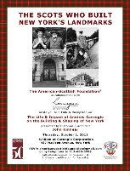
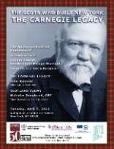
Andrew Carnegie is the ultimate "rags to riches story" in the history of the United States and two talks have been undertaken around Carnegie and his Legacy. Carnegie’s contributions to industry and in particular the impact of the steel industry are examined, for it is steel which changed the way we build.
Through Carnegie’s philanthropy buildings were built and thousands of libraries created around the world. New York became Andrew's home and he left us many buildings which to this day are dynamic city treasures. What made Carnegie? This we attempt to discover in The Life & Impact of Andrew Carnegie on the Building & Shaping of New York.
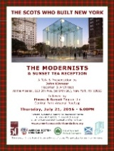
1880 onwards - The Modernist period begins in 1880. Carnegie’s steel has made tall buildings possible and economical, Otis’s elevators have made height accessible. Architects have been released from the bounds of masonry supported buildings. New expression of forms and greater use of glass is now possible. Engineering becomes the partner of the architect in the design of buildings ever taller and ever more efficient.
____________________________________________________________________________________
Research and development of The Scots Who Built New York has been undertaken by:
JOHN KINNEAR, Principal of John Kinnear Architects and President of the American Friends of the Georgian Group, has an architectural practice based in Manhattan, which undertakes projects throughout the United States.
Recent projects include the restoration of the Ruth Mansion in Delaware, 26 Commerce Street in Greenwich Village, and The Queen Elizabeth II September 11th Garden in Hanover Square for which he was the Project Architect. The firm is noted for its historical preservation as well as new structures incorporating traditional design styles.
____________________________________________________________________________________
SPONSORSHIP of The Scots Who Built New York
– Recognition on upcoming Scots Who Built New York materials, through website, logo and links
- Event opportunities
Sponsorship Opportunities:
Platinum $15,000
Associate $ 7,500
Patron $ 2,500
Friend $ 1,000
Contributor $ ............

General Funding of the ASF Arts & Culture Program
Arts Patron $ 5,000
Arts Supporter $ 2,000
Arts Friend $ 500
Arts Contributor $ ............

THE SCOTS WHO BUILT NEW YORK
PAYMENT FORM

Sponsorship Opportunities
□ Platinum $15,000
□ Associate $ 7,500
□ Patron $ 2,500
□ Friend $ 1,000
□ Contributor $ ............
General Funding of the ASF Arts & Culture Program
□ Arts Patron $ 5,000
□ Arts Supporter $ 2,000
□ Arts Friend $ 500
□ Arts Contributor $ ............
My company will match my gift. The form is enclosed.
The American-Scottish Foundation® is a non-profit 501(c)(3) organization. Donations are tax-deductible to the extent of the law.

PAYMENT DETAILS
Name (please print) ____________________________________________

Day phone ____________________________________________________

E-mail ________________________________________________________

Address _______________________________________________________

City _________________________ State _______ Zip ___________

□ I enclose my check, payable to The American-Scottish Foundation, Inc. for: $ ______

□ Please charge my credit card □ Visa □ Mastercard □ American Express: $ ______

Card#______________________________Exp.___ /____ Code ______
Signature ______________________________________________________

The American-Scottish Foundation, Inc.
Scotland House®, 575 Madison Avenue, 10th Floor, New York, New York 10022-2511
Tel: 212-605-0338 Fax: 212-605-0222 E-mail: americanscottishfoundation@gmail.com
www.americanscottishfoundation.org

